Curved Boundary in Solid Geometry

Definition
# Source: AI Source: Provided by: [Data Path: Persons Table -> ID Column: 1, Name_En Column: Motasem Essam] -> From: [ChatGPT] on [7/25/2026]
A curved boundary in solid geometry is a surface that contains curved portions and forms all or part of the outer boundary of a three-dimensional solid. Unlike a polyhedral boundary, which consists entirely of flat polygonal faces, a curved boundary includes surfaces that bend continuously through space.
Curved boundaries appear in solids such as spheres, cylinders, cones, ellipsoids, and curved portions of more complex objects. Depending on the solid, the boundary may be entirely curved or combine curved surfaces with flat faces.
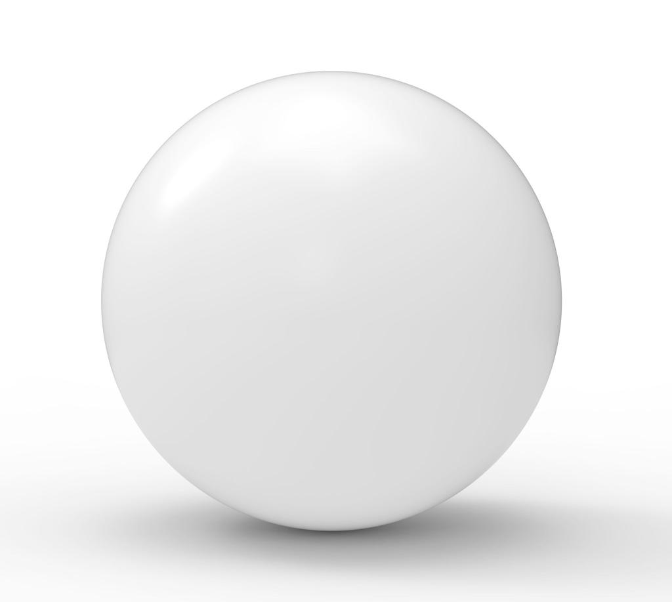

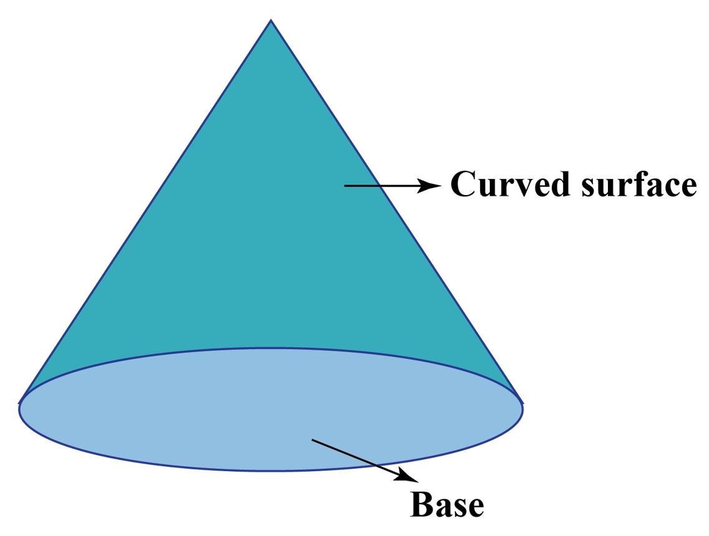

Simple Definition
# Source: AI Source: Provided by: [Data Path: Persons Table -> ID Column: 1, Name_En Column: Motasem Essam] -> From: [ChatGPT] on [7/25/2026]
A curved boundary is the outer surface of a solid that bends rather than consisting entirely of flat polygonal faces.
Examples include:
- The spherical surface of a ball.
- The curved side of a cylinder.
- The curved side of a cone.
- The smooth surface of an ellipsoid.
A cylinder and a cone also have flat faces, so their complete boundaries are not entirely curved. Their lateral surfaces are curved, while their bases are flat.

Key Characteristics
# Source: AI Source: Provided by: [Data Path: Persons Table -> ID Column: 1, Name_En Column: Motasem Essam] -> From: [ChatGPT] on [7/25/2026]
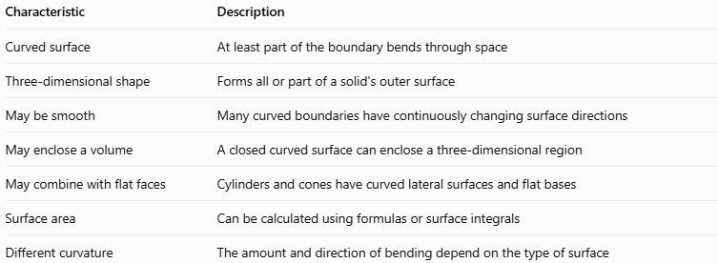
Characteristic | Description
Curved surface | At least part of the boundary bends through space
Three-dimensional shape | Forms all or part of a solid's outer surface
May be smooth | Many curved boundaries have continuously changing surface directions
May enclose a volume | A closed curved surface can enclose a three-dimensional region
May combine with flat faces | Cylinders and cones have curved lateral surfaces and flat bases
Surface area | Can be calculated using formulas or surface integrals
Different curvature | The amount and direction of bending depend on the type of surface
Important: A curved boundary is not necessarily a closed surface. For example, the lateral surface of a cylinder without its two bases is curved but open. Adding the circular bases creates the complete closed boundary of a finite cylinder.

Geometric Representation
# Source: AI Source: Provided by: [Data Path: Persons Table -> ID Column: 1, Name_En Column: Motasem Essam] -> From: [ChatGPT] on [7/25/2026]
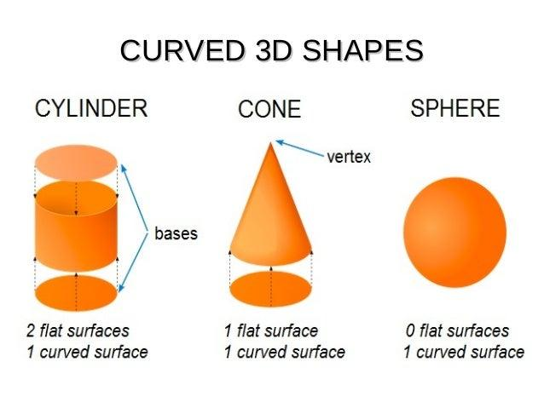
The following examples show different types of curved boundaries.

Spherical boundary
# Source: AI Source: Provided by: [Data Path: Persons Table -> ID Column: 1, Name_En Column: Motasem Essam] -> From: [ChatGPT] on [7/25/2026]
A smooth, closed surface whose points are all the same distance from the sphere's center.
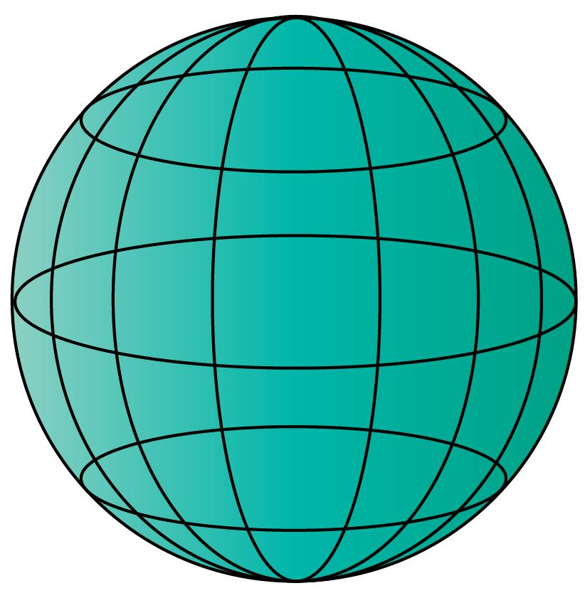

Cylindrical boundary
# Source: AI Source: Provided by: [Data Path: Persons Table -> ID Column: 1, Name_En Column: Motasem Essam] -> From: [ChatGPT] on [7/25/2026]
The lateral surface curves around the axis, while the circular ends are flat.

Conical boundary
# Source: AI Source: Provided by: [Data Path: Persons Table -> ID Column: 1, Name_En Column: Motasem Essam] -> From: [ChatGPT] on [7/25/2026]
The lateral surface narrows toward the apex, meeting the flat circular base at its rim.

Ellipsoidal boundary
# Source: AI Source: Provided by: [Data Path: Persons Table -> ID Column: 1, Name_En Column: Motasem Essam] -> From: [ChatGPT] on [7/25/2026]
A smooth, closed surface resembling a stretched or compressed sphere.
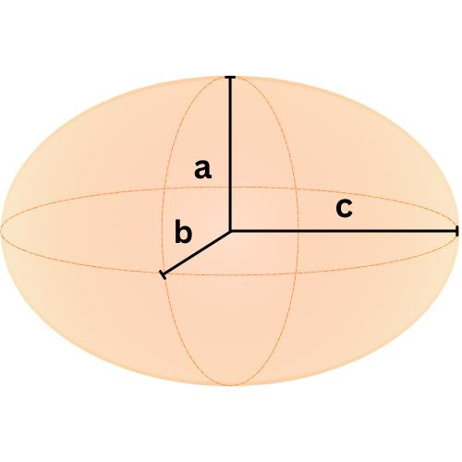

Mathematical Representation

Spherical boundary
# Source: AI Source: Provided by: [Data Path: Persons Table -> ID Column: 1, Name_En Column: Motasem Essam] -> From: [ChatGPT] on [7/25/2026]
A sphere of radius $r$, centered at the origin, has the surface equation
$$x^{2}+y^{2}+z^{2}=r^{2}$$
Every point on the boundary is exactly $r$ units from the origin.
The corresponding interior region satisfies
$$x^{2}+y^{2}+z^{2}<r^{2}$$

Cylindrical boundary
# Source: AI Source: Provided by: [Data Path: Persons Table -> ID Column: 1, Name_En Column: Motasem Essam] -> From: [ChatGPT] on [7/25/2026]
A circular cylinder of radius $r$ with its axis along the $z$-axis has the lateral surface equation
$$x^{2}+y^{2}=r^{2}$$
If the cylinder extends between $z=0$ and $z=h$, its lateral surface is restricted by
$$0≤z≤h$$
The complete boundary also includes the two circular bases at $z=0$ and $z=h$.

Conical boundary
# Source: AI Source: Provided by: [Data Path: Persons Table -> ID Column: 1, Name_En Column: Motasem Essam] -> From: [ChatGPT] on [7/25/2026]
A right circular cone with its apex at the origin and axis along the positive $z$-axis can be described by
$$x^{2}+y^{2}=z^{2}\tan^{2}{θ}$$
where $θ$ is the angle between the cone's axis and its sloping side, with $z≥0$.
For a finite cone with height $h$, restrict $z$ to $0≤z≤h$. Its complete boundary includes the curved lateral surface and the circular base.

Ellipsoidal boundary
# Source: AI Source: Provided by: [Data Path: Persons Table -> ID Column: 1, Name_En Column: Motasem Essam] -> From: [ChatGPT] on [7/25/2026]
An ellipsoid centered at the origin can be represented by
$$\frac{x^{2}}{a^{2}}+\frac{y^{2}}{b^{2}}+\frac{z^{2}}{c^{2}}=1$$
where $a$, $b$, and $c$ are positive semi-axis lengths.
If $a=b=c$, the ellipsoid becomes a sphere. If the semi-axis lengths differ, the surface is stretched or compressed along one or more axes.

Surface area
# Source: AI Source: Provided by: [Data Path: Persons Table -> ID Column: 1, Name_En Column: Motasem Essam] -> From: [ChatGPT] on [7/25/2026]
For a sphere of radius $r$, the total curved surface area is
$$A=4πr^{2}$$
For a right circular cylinder of radius $r$ and height $h$, the lateral curved surface area is
$$A_{\text{lateral}}=2πrh$$
For a right circular cone with base radius $r$ and slant height $l$, the lateral curved surface area is
$$A_{\text{lateral}}=πrl$$
These formulas calculate specific curved surfaces; they do not necessarily represent the total boundary area when flat bases are also present.

Worked Examples
# Source: AI Source: Provided by: [Data Path: Persons Table -> ID Column: 1, Name_En Column: Motasem Essam] -> From: [ChatGPT] on [7/25/2026]
Example 1: Calculate the curved surface area of a sphere
A sphere has a radius of $4$ cm. Find its boundary surface area.
Solution:
The surface area of a sphere is
$$A=4πr^{2}$$
Substitute $r=4$:
$$A=4π{\left(4\right)}^{2}=64π$$
Therefore, the curved boundary has an area of
$$\boxed{64π{\text{ cm}}^{2}≈201.06{\text{ cm}}^{2}}$$
Example 2: Calculate the lateral surface area of a cylinder
A cylinder has a radius of $3$ cm and a height of $7$ cm. Find its curved lateral surface area.
Solution:
Use
$$A_{\text{lateral}}=2πrh$$
Substituting the values:
$$A_{\text{lateral}}=2π\left(3\right)\left(7\right)=42π$$
The lateral curved surface area is
$$\boxed{42π{\text{ cm}}^{2}≈131.95{\text{ cm}}^{2}}$$
This excludes the two circular bases.
Example 3: Calculate the curved surface area of a cone
A cone has a base radius of $5$ cm and a slant height of $8$ cm.
Solution:
The lateral surface area is
$$A_{\text{lateral}}=πrl$$
Substitute $r=5$ and $l=8$:
$$A_{\text{lateral}}=π\left(5\right)\left(8\right)=40π$$
Therefore,
$$\boxed{40π{\text{ cm}}^{2}≈125.66{\text{ cm}}^{2}}$$
The area of the flat circular base is not included.
Example 4: Identify the type of boundary
Consider the equation
$$x^{2}+y^{2}+z^{2}=49$$
Solution:
This is the equation of a sphere centered at the origin.
Its radius is
$$r=\sqrt{49}=7$$
Therefore, the equation represents a spherical boundary with radius $7$ units.

Comparison With Related Concepts
# Source: AI Source: Provided by: [Data Path: Persons Table -> ID Column: 1, Name_En Column: Motasem Essam] -> From: [ChatGPT] on [7/25/2026]
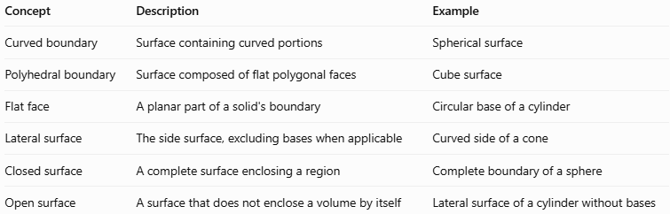
Concept | Description | Example
Curved boundary | Surface containing curved portions | Spherical surface
Polyhedral boundary | Surface composed of flat polygonal faces | Cube surface
Flat face | A planar part of a solid's boundary | Circular base of a cylinder
Lateral surface | The side surface, excluding bases when applicable | Curved side of a cone
Closed surface | A complete surface enclosing a region | Complete boundary of a sphere
Open surface | A surface that does not enclose a volume by itself | Lateral surface of a cylinder without bases

Applications
# Source: AI Source: Provided by: [Data Path: Persons Table -> ID Column: 1, Name_En Column: Motasem Essam] -> From: [ChatGPT] on [7/25/2026]
- Architecture: Designing domes, curved roofs, and cylindrical structures.
- Engineering: Modeling pipes, tanks, pressure vessels, and rounded components.
- Manufacturing: Calculating material requirements for curved parts.
- Computer graphics: Rendering curved surfaces and representing them with mathematical models.
- Physics: Describing the surfaces of spherical objects and cylindrical systems.
- Calculus: Computing surface areas, flux, and other quantities over curved surfaces.

Key Points
# Source: AI Source: Provided by: [Data Path: Persons Table -> ID Column: 1, Name_En Column: Motasem Essam] -> From: [ChatGPT] on [7/25/2026]
- A curved boundary contains curved surface portions.
- Spheres and ellipsoids have entirely curved, closed boundaries.
- Cylinders and cones combine curved lateral surfaces with flat bases when complete.
- A curved surface can be open or closed.
- Surface area depends on the shape and dimensions of the boundary.
- Curved boundaries differ from polyhedral boundaries, which consist of flat polygonal faces.

Conclusion
# Source: AI Source: Provided by: [Data Path: Persons Table -> ID Column: 1, Name_En Column: Motasem Essam] -> From: [ChatGPT] on [7/25/2026]
A curved boundary in solid geometry is a surface that bends through three-dimensional space and forms all or part of a solid's outer boundary. Spheres, cylinders, cones, and ellipsoids are common examples. Understanding curved boundaries helps with surface-area calculations, solid modeling, and the mathematical description of three-dimensional objects.

